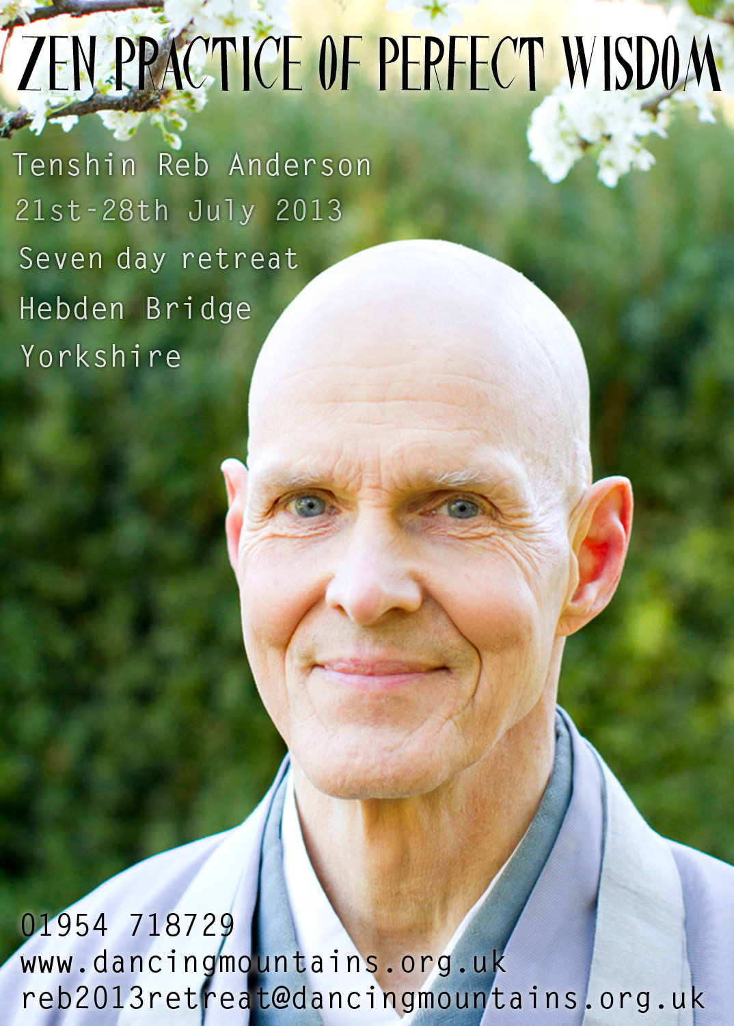
Reb Anderson, Tenshin Roshi is a lineage-holder in the Soto Zen tradition. Born in Mississippi, he grew up in Minnesota and left advanced study in mathematics and western psychology to come to Zen Center in 1967. He practiced with Suzuki Roshi, who ordained him as a priest in 1970 and gave him the name Tenshin Zenki ("Naturally Real, The Whole Works"). He received dharma transmission in 1983 and served as abbot of San Francisco Zen Center's three training centers (City Center, Green Gulch Farm and Tassajara Zen Mountain Center) from 1986 to 1995. Tenshin Roshi continues to teach at Zen Center, living with his family at Green Gulch Farm. He is author of ‘Warm Smiles from Cold Mountains: Dharma Talks on Zen Meditation’, ‘Being Upright: Zen Meditation and the Bodhisattva Precepts’ and ‘The Third Turning of the Wheel: Wisdom of the Samdhinirmocana Sutra’.
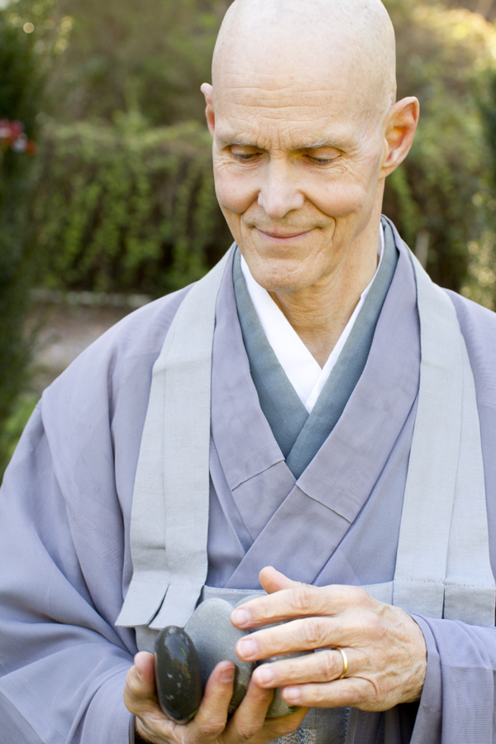
You may arrive after 3pm on Sunday 21 July and the retreat will start officially at 7pm – please indicate your arrival time so that we know if you will be with us for dinner and if you are not able to arrive before 6pm, please let us know. It will end after lunch on Sunday 28 July.

The retreat will be held primarily in silence. It will include traditional Zen forms and ceremonies and will follow a set schedule. Instruction for newcomers will be given. There will also be opportunity to ask questions of the teacher.

Accommodation is in shared bedrooms (gender separate) or in personal tents near the zendo. We will be offering wholesome vegetarian food that will be primarily vegan. Please bring your own sitting gear or contact us if you require some. Information about travelling to Hebden Bridge will be sent with confirmation of registration.

To book, please send the booking form below with a non-refundable deposit of £100 by 25 May 2013, to Wendy Klein, 6 Roe Walk, Cambourne CB23 6EJ. You may also return the information and/or form via email to the address below. We are asking for payment in full by 1 July please.

Please print clearly.
Name: ___________________________________ Email: ___________________________________________________
Mobile: __________________________________
Address: _____________________________________________________________________________________________
Have you meditated before and if so, with which tradition (if any)? _____________________________________________________________________________________________________
How will you travel to the retreat and would you be willing to offer a lift to someone else? _____________________________________________________________________________________________________
BACS Details: Dancing Mountains,
The Co-operative Bank,
Acc. number: 65323036; Sort code: 08-92-99
Use your name as the reference code.
Payment type: by cheque  (payable to ‘Dancing Mountains’)
by BACS  (email when payment is made)

Accommodation choice: Shared room in hostel fee to pay: …… £375 …… £385 (supporter rate)
……………………… …… £365 (basic rate)
Camping …………………………………………………… £300 …… £310 (supporter rate)
……………………… …… £290 (basic rate)
Other _______________ please specify …… £300 …… £310 (supporter rate)
……………………… …… £290 (basic rate)
We are inviting participants to contribute £10 or £20 towards a bursary fund that will assist those who find the basic rate difficult to manage, hence the supporter rate. This is not required but others would be grateful if you were able to contribute. If you cannot manage the basic rate, please email Wendy with what you can afford and if there is sufficient in the bursary fund, we may be able to offer a discounted rate.
To book, I enclose:  The full fee / or /  £100 Deposit. Note: payment in full by 1 July please

This retreat is suitable for beginners.

Enquiries to Wendy: reb2013retreat@dancingmountains.org.uk or 01954 718729

